

PUSL3190 Computing Project

Project Proposal

Socially Aware Embodied Language Agent

Supervisor: Ms. Dulanjali Wijesekara

Name: Galgana A Gamlath
Plymouth Index Number: 10953516
Degree Program: BSc. (Honors) Computer Science

Table of Contents

Chapter 01 Problem Statement 3
Chapter 02 Project Description 4
Project Keywords 5
Related Areas 6
Chapter 03 Research Gap 7
Chapter 04 Requirements Analysis 10
Functional Requirements 10
Non-Functional Requirements 12
User Requirements 13
Methods Used 13
Devices / Knowledge 13
Use Case Diagram for SELA 14
Diagram for SELA 15
Chapter 05 Finance 16
Budget Plan 16
Justification: - 16
Chapter 06 External Organizations 17
External Partners / Roles 17
Other Staff 17
Chapter 07 Timeline 18
References 19

Chapter 01 Problem Statement

Conversational agents have become a core component of modern human-computer interaction, reshaping how people engage with technology across sectors such as education, healthcare, and customer service worldwide (Sinan Sonlu, 2024) International organizations such as the United Nations (Anon., 2023) and large technology firms like Google and OpenAI have highlighted the growing role of AI-driven conversational tools and their potential to enhance engagement and inclusion across borders (Che-Jui Chang, 2023). Countries across Europe, Asia, and North America have also implemented national strategies to integrate intelligent conversational assistants into public services and learning platforms, as early as 2018 (Hailun Lian, 2023).

Despite rapid advances in large language models that enable coherent, contextually relevant dialogue. Most systems today rely primarily on text-based inputs and fail to capture users’ emotional states and personalities in meaningful ways, leaving interactions mechanical and detached (Andrei Nosov, 2024). In Sri Lanka, undergraduate research projects and local tech initiatives are beginning to explore voice and avatar-based conversational systems. However, most systems still rely on simple question and answer designs rather than genuine multimodal and empathetic communication (Simon Christophe Jolibois, 2025).

Existing chatbots generate fluent responses but cannot interpret critical multimodal cues, such as facial expressions, tone of voice, and prosody, that are essential for natural human communication (Kumar Shubham, 2022). Embodied Conversational Agents with avatars often use scripted animations that are not responsive to real-time emotional signals, limiting their capacity to build trust or sustain long-term engagement (Che-Jui Chang, 2023). While previous research has addressed emotion-aware or personality-driven dialogue systems, very few frameworks integrate emotion detection from visual and auditory cues, Large Language Model reasoning, and embodied adaptive expression into a single, cohesive solution (Sinan Sonlu, 2024) (Che-Jui Chang, 2023).

The specific problem tackled by the Socially Aware Embodied Language Agent project is this: although several attempts exist, no one currently delivers a lightweight, real-time, multimodal conversational agent that combines emotion sensing, personality inference, and embodied avatar interaction. Existing frameworks are either limited to a single modality, lack real-time adaptation, or require substantial computational resources, making them unsuitable for scalable or educational use (Andrei Nosov, 2024). The Socially Aware Embodied Language Agent project aims to bridge these gaps by developing a system that senses user voice and facial cues, infers personality traits, reasons with a Large Language Model, and responds through an animated avatar that creates natural, empathetic, socially intelligent interaction within a unified, efficient architecture (Sinan Sonlu, 2024).

Chapter 02 Project Description

The project explains how the proposed system aims to address the identified problem, providing a clear overview of its goals. The main structure of the proposal delivers the background, objectives, scope, and expected outcomes.

- Background and Rationale

Conversational agents have improved more with the help of Large Language Models. It can make communication between humans and AI feel more natural and engaging. However, most existing systems are still text-based. They lack emotional understanding, and user feels that their interactions are robotic and impersonal. This emotional gap erodes users’ trust, empathy, and engagement across education, healthcare, and customer service. (Simon Christophe Jolibois, 2025)

The Socially Aware Embodied Language Agent aims to solve this problem by enabling the system to understand emotions from facial expressions and vocal tone. This can intelligently respond using advanced language models.

The system becomes more socially intelligent by identifying users' personality traits and emotions in real time. Then this system can communicate with each user with greater understanding and empathy. This project aims to show how people interact with AI through multiple forms of expression and emotionally aware computing.

- Objectives

The objectives of the SELA project are as follows,

- Develop a multimodal conversational agent that integrates visual (facial expressions) and audio (speech, prosody) signals to enable real-time understanding of user affective states.

- Design and implement affect inference models that can reliably estimate user emotions (valence–arousal, discrete emotions) and provide lightweight personality trait cues from short interactions.

- Integrate affect-awareness into language generation, enabling the conversational agent to adapt its content and tone dynamically according to the user’s inferred emotional and personality states.

- Introduce response optimization in Large Language Model for real time performance using models such as Small Language Model and prompt optimization technique (e.g., textgrad)

- Create an embodied interface where an avatar visually reflects the agent’s adaptive conversational style, enhancing user perception of empathy and engagement.

- Evaluate the effectiveness of the system through both quantitative metrics (accuracy, latency, text quality) and qualitative user studies, to assess improvements in naturalness, empathy, and user satisfaction.

- Scope

The project focuses on developing a prototype conversational agent that can identify emotions, adapt its dialogue to the user’s state, and deliver meaningful responses through an animated avatar. (Sinan Sonlu, 2024)
- In-scope - Emotion detection from facial and voice signals, personality estimation, integration with a Large Language Model, and avatar-based visual embodiment.
- Out-of-scope - Large-scale deployment, multi-language support, or extended domain-specific knowledge bases.
The project is limited to research and prototype development. This project is mainly for educational and experimental purposes.

- Expected Outcomes

- Demonstrate real-time emotion and personality inference through multimodal input (face and voice).
- Generate emotionally aligned, adaptive, and context-aware responses using Large Language Models.
- Present an embodied avatar capable of mirroring the conversational tone and emotional state dynamically.
- Achieve improved user engagement, empathy perception, and interaction satisfaction in evaluations.
- Contributes to the advancement of socially aware AI for educational, therapeutic, and interactive systems.

Project Keywords

Socially aware Embodied Language Agent (SELA), Multimodal Conversational Agent, Emotion Recognition, Personality-aware AI, Embodied AI, Large Language Models (LLMs), Affective Computing, Human-Computer Interaction (HCI), Natural Language Processing (NLP), Embodied Conversational Agents (ECAs)

Related Areas

1. Affective Computing
2. Natural Language Processing (NLP)
3. Speech Processing & Prosody Analysis
4. Computer Vision (Facial Expression Recognition)
5. Embodied Conversational Agents & Human-Computer Interaction

Chapter 03 Research Gap

Over the past decade, advances in LLMs, speech recognition, and computer vision have advanced conversational AI (Tadas Baltrušaitis, 2019) , (Sidney K. D'mello, 2015) But most systems are still text-based and emotionally neutral. (Soujanya Poria, 2017) , (Hailun Lian, 2023)They can logically communicate but lack empathy, emotions, or awareness of user personality.

Previous studies explored emotional recognition, personality modeling, and embodied interaction. But few merged with all three. For Example, LLM-based educational agents show that conversations are more engaging when personality and visual embodiment are added, and multimodal ECAs can detect emotions from faces and voices. (Sinan Sonlu, 2024), (Che-Jui Chang, 2023). Emotionally aware chatbots change the tone but rarely connect understanding, reasoning, and expression in real time. (Shubham, et al., 2022), (Che-Jui Chang, 2023), (Sidney K. D'mello, 2015), (Soujanya Poria, 2017)
This creates a technical and methodological gap: systems that can detect emotions often fail to express them appropriately, while those that can express emotions usually do not truly understand them (Tadas Baltrušaitis, 2019). Many current frameworks are also too complex to run on small devices or in real time. (Shubham, et al., 2022), (Che-Jui Chang, 2023), (Naveed Ahmed, 2023).
The Socially aware Embodied Language Agent bridges this gap through a lightweight, multimodal framework that combines emotion and personality inference, adaptive LLM reasoning, and expressive embodiment. This system enables both emotional understanding and response by contributing to socially intelligent, empathetic AI.
Common Types of Gaps
• Knowledge - Few studies combine emotion, personality, and embodiment in one framework.
• Technology - Lack of efficient real-time multimodal systems.
• Methodological - Emotion and dialogue modules are usually tested separately.
• Contextual - Limited adaptation to cultural and personality diversity.

Table 1: Research Gap
Sources | Contribution | Limitations and Identified Gap | How SELA Addresses It
(Soujanya Poria, 2017) | Reviewed affective computing from unimodal to multimodal systems. | Most systems rely on a single input (text or voice) and lack integrated affect understanding. | SELA fuses audio + visual emotion sensing with adaptive reasoning.
(Hailun Lian, 2023) | Surveyed deep learning-based multimodal emotion recognition (MER). | MER models achieve accuracy but lack real-time adaptation and cross-cultural robustness. | SELA applies lightweight real-time affect inference models for live interaction.
(Naveed Ahmed, 2023). | Systematic review of MER architectures and datasets. | Existing multimodal systems are computationally heavy and unsuitable for real-time or edge use. | SELA designs low-latency, resource-efficient architecture that can be deployed on standard hardware.
(Shubham, et al., 2022) | Discussed ECA architectures for commercial applications. | ECAs use scripted logic, failing to synchronize understanding, reasoning, and emotional expression. | SELA integrates all modules—emotion, reasoning, embodiment—into a cohesive adaptive pipeline.
(Sinan Sonlu, 2024) | Analyzed embodiment and personality expression in LLM-based educational agents. | Personality expression improves engagement but lacks integration with emotion awareness. | SELA links personality cues to emotion inference to enable socially aware responses.
(Che-Jui Chang, 2023) | Studied multimodal emotion conditioning and affect consistency in ECAs. | Emotional conditioning exists, but agents still lack real-time adaptation and personalization. | SELA continuously affects sensing and LLM-driven response adaptation.
(Andrei Nosov, 2024) | Proposed a deep-learning-based multimodal sentiment analysis framework for ECAs. | Focused on emotion recognition only, without reasoning or embodied response generation. | SELA extends to emotion, reasoning, and embodiment, bridging perception and expression.
(Simon Christophe Jolibois, 2025) | Evaluated emotional ECAs and the effect of response delay on user impression. | Found that latency harms user experience; most systems fail to manage delay effectively. | SELA emphasizes <2.5s latency through optimized pipelines.
(Schuller, 2018) | Surveyed two decades of speech emotion recognition. | SER models are accurate but not integrated with visual and reasoning systems. | SELA fuses voice and vision for richer emotion recognition.
(Tadas Baltrušaitis, 2019) | Defined taxonomy for multimodal machine learning. | Theoretical survey — lacks practical fusion in conversational contexts. | SELA applies fusion and alignment principles to dialogue modeling.
(Zhang, 2025) | Investigated user navigation in emotion-aware conversational agents. | Focused on emotional expression but not multimodal understanding. | SELA combines affect sensing + embodied interaction for adaptive empathy.

Chapter 04 Requirements Analysis

Requirements analysis defines what the system must achieve and how it should perform. It reduces risk and guides implementation to meet user needs.
The requirements of this project were gathered by studying existing conversational agents and understanding what users expect from empathetic, multimodal interactions. (Hailun Lian, 2023)

Functional Requirements

- User Input-Capture voice + 2D Video; transcribe speech (STT e.g: - Faster-Whisper); extract contextual traits.
- Processing-Convert audio to text; recognize facial emotions; optionally infer demographics/personality; combine features into an LLM prompt; generate socially aware responses; maintain dialogue context.
- Output- Animate a 2D avatar with emotion-matched expressions and speech; convert text to audio; display both transcription + response.
- System Interaction- Continuous hands-free conversation with emotion-adaptive replies.

Table 2: Functional Requirements
Category | Functional Requirement | Description
User Input | Voice Capture | The system must capture user speech in real time from a microphone.
 | 2D Video Capture | The system must capture the user’s facial expressions using a webcam.
 | Speech-to-Text (STT) | Transcribe user speech into text using an automatic STT engine (e.g., Faster-Whisper).
 | Context Extraction | Extract contextual information, such as emotion, personality, and demographic traits, from speech and visual inputs.
Processing | Audio-to-Text Conversion | Convert spoken audio to textual input for processing by the LLM.
 | Emotion Recognition | Detect facial emotions (e.g., happy, sad, angry, neutral) using visual inference.
 | Personality Inference (Optional) | Optionally infer lightweight personality traits from short interactions.
 | Feature Fusion | Combine multimodal features (audio, visual, and text) into a structured prompt for the language model.
 | Response Generation | Use an LLM to produce socially aware, context-sensitive responses.
 | Dialogue Management | Maintain conversational context across multiple dialogue turns.
Output | Avatar Animation | Display a 2D animated avatar that visually expresses emotions in real time.
 | Text-to-Speech (TTS) | Convert generated text responses into spoken audio.
 | Response Display | Show both the transcribed user input and the generated response text on the interface.
System Interaction | Real-Time Conversation | Ensure seamless, hands-free communication between the user and the system.

Non-Functional Requirements

- 2-3 s latency for real-time performance.
- Adequate STT / FER accuracy.
- Scalability across LLMs (GPT, Phi-3, InternVideo2.5)
- Extensibility for new traits (e.g, stress detection).
- Cross-platform compatibility with camera/mic.
- Ethical data handling and privacy protection.

Table 3: Non-Functional Requirements
Attribute | Non-Functional Requirement | Description
Performance | Low Latency | The system must provide real-time responses within 2–3 seconds to maintain natural interaction.
Accuracy | Reliable STT / FER | Maintain acceptable speech-to-text and facial emotion recognition accuracy for continuous conversational use.
Scalability | Model Flexibility | Support multiple LLMs (e.g., GPT, Phi-3, InternVideo 2.5) without significant architecture changes.
Extensibility | Trait Expansion | Allow easy integration of new affective traits, such as stress or engagement detection, in future updates.
Compatibility | Cross-Platform Operation | Ensure smooth operation on devices supporting camera and microphone inputs (desktop, laptop, or web).
Privacy | Secure Data Handling | Adhere to ethical standards, user consent, data anonymization, and privacy protection during all data capture and storage.

User Requirements
Natural, voice-based interaction, emotionally adaptive responses, real-time feedback, no technical setup required.

Table 4: User Requirements
User Requirements | Description
Natural Voice Interaction | Users should be able to communicate naturally with the system through speech without typing or manual input.
Emotionally Adaptive Responses | The system should recognize the user’s emotional state and adapt its tone and responses empathetically.
Real-Time Feedback | The system should provide instant visual and audio feedback (e.g., avatar animation and spoken reply) to maintain conversational flow.
Ease of Use and User Friendliness | Users should be able to interact with SELA without any technical setup or configuration, plug in, and start speaking.
Continuous Engagement | The system should maintain an ongoing, context-aware conversation, preserving context across multiple turns.

Methods Used
Interviews and focus groups, surveys and observation, literature review, and analysis of existing chatbots (ChatGPT, Meta AI Studio).

Devices / Knowledge
GPU-enabled computer with webcam + microphone, Python + PyTorch with OpenCV, Whisper, TTS, and avatar animation libraries.

Use Case Diagram for SELA

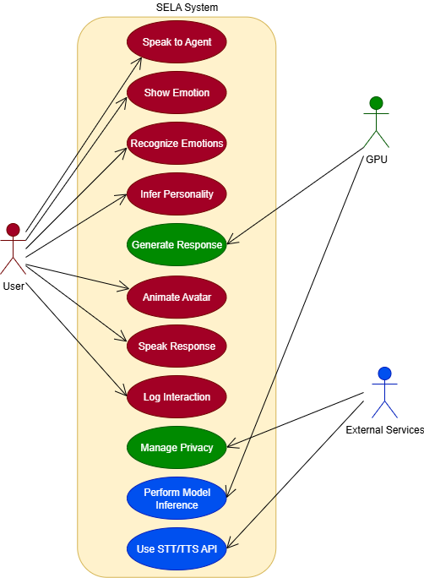

Figure 1: SELA Use Case Diagram

Diagram for SELA

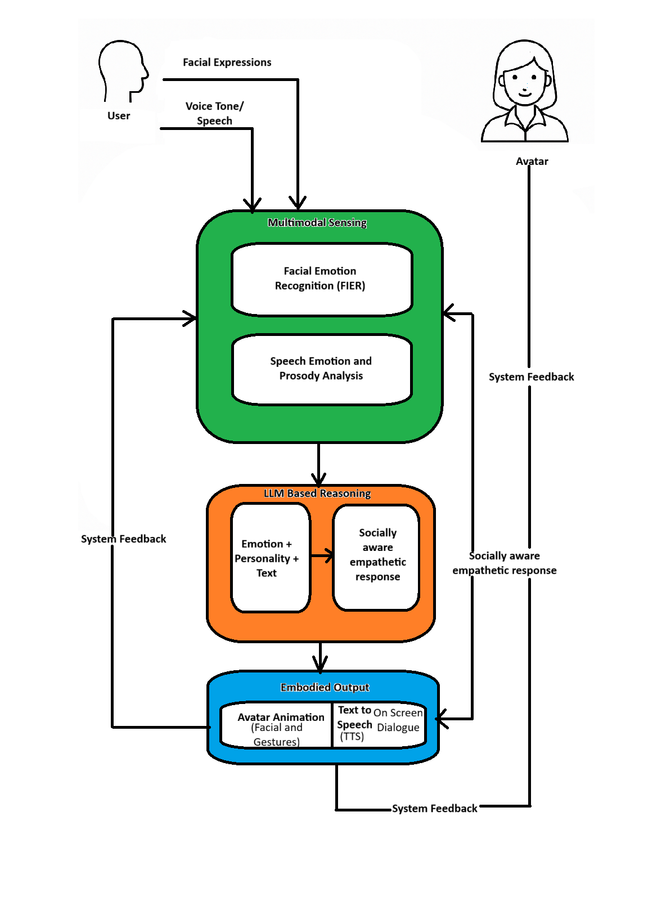
Figure 2: SELA Diagram

Chapter 05 Finance

Budget Plan

Table 5: Budget Plan
Item | Description | Estimated Cost (LKR)
GPU/Cloud Credits | Model training and real-time testing | 65 000
Web cam and Microphone | Facial and voice input capture | 15 000
Avatar Animation Tool | Rendering and speech animation | 30 000
Miscellaneous (storage, Hosting, API) | Data storage and maintenance | 10 000
Total |  | 120 000 LKR

Justification: -
All costs directly support the system's real-time emotion recognition and avatar interaction. The GPU enables faster model processing, the webcam and microphone collect facial and voice data, and the animation tools create a more expressive, realistic avatar.

Chapter 06 External Organizations

External collaboration supports resource access and technical validation. The project relies on public datasets (NOXI, AffectNet) and academic guidance for evaluation and optimization.

External Partners / Roles

- Industry / Research Institutes – Consultation and GPU access.
- Academic Collaborators – Model design and affective computing advice.

Other Staff

- Supervisor –Academic oversight and progress review.
- Research Assistants – Prototype testing and data support.
- Peer Collaborators – Usability feedback and evaluation.

Chapter 07 Timeline

The timeline outlines an organized flow of activities from the start of analysis to the completion of the project.

Figure 3: Gannt Chart for SELA project timeline over 7 months from analysis to submission.

References

- Andrei Nosov, S. S. A. L., 2024. Embodied Conversational Agents: Deep Learning Based Multimodal Sentiment Analysis.

- Anon., 2023. Artificial Intelligence and Human Development: Opportunities and Challenges for Inclusive and Ethical AI, New York: United Nations Development Programme (UNDP).

- Che-Jui Chang, S. S. S. S. Z. R. J. M. U. M. K., 2023. The Importance of Multimodal Emotion Conditioning and Affect Consistency for Embodied Conversational Agents.

- Hailun Lian, C. L. ,. L. Z. T. Y. Z., 2023. A Survey of Deep Learning-Based Multimodal Emotion Recognition: Speech, Text, and Face.

- Kumar Shubham, L. N. N. V. D. B. J. R. T., 2022. Multimodal Embodied Conversational Agents: A discussion of architectures, frameworks and modules for commercial applications.

- Naveed Ahmed, Z. A. A. G., 2023. A systematic survey on multimodal emotion recognition using learning algorithms.

- Schuller, B. W., 2018. Speech emotion recognition: two decades in a nutshell, benchmarks, and ongoing trends.

- Shubham, K., Venkatesan, L. N. N., Jayagopi, D. B. & Tumuluri, R., 2022. Multimodal Embodied Conversational Agents: A discussion of architectures, frameworks and modules for commercial applications.

- Sidney K. D'mello, J. K., 2015. A Review and Meta-Analysis of Multimodal Affect Detection Systems.

- Simon Christophe Jolibois, A. I. T. N., 2025. The Development of an Emotional Embodied Conversational Agent and the Evaluation of the Effect of Response Delay on User Impression.

- Sinan Sonlu, B. B. F. D. U. G., 2024. The Effects of Embodiment and Personality Expression on Learning in LLM-based Educational Agents.

- Soujanya Poria, E. C. ,. R. B. ,. H., 2017. A review of affective computing: From unimodal analysis to multimodal fusion.

- Tadas Baltrušaitis, C. A. L.-P. M., 2019. Multimodal Machine Learning: A Survey and Taxonomy..

- Tom B. Brown, B. M. N. R. M. S. J. K. P. D. A. N. P. S. G. S. A. A. S. A. A. H.-V. G. K. T. H. R. C. A. R. D., 2020. Language Models are Few-Shot Learners.
- Zhang, Y. M. Y. ,. D. F. P. S. F. M. K. D., 2025. Navigating Users in Emotion-Aware Conversational Agents: Exploring Strategies for Enhanced Interaction.

